**Kali Linux** is a powerful, Debian-based Linux distribution specifically designed for penetration testing, ethical hacking, and digital forensics. Developed and maintained by Offensive Security, Kali is widely used by cybersecurity professionals, ethical hackers, and researchers around the world.

This distribution has [several hundred tools, configurations, and scripts](https://www.kali.org/features/) with [industry-specific modifications](https://www.kali.org/docs/policy/penetration-testing-tools-policy/) that allow users to focus on tasks such as computer forensics, reverse engineering, and vulnerability detection, instead of dealing with unrelated activities. This distribution is specifically tailored to the needs of experienced penetration testers, so all documentation on this site assumes prior knowledge of, and familiarity with, the Linux operating system in general.

### **Key Features of Kali Linux:**

* **Pre-installed Security Tools**: Comes with over 600 tools for information gathering, vulnerability analysis, wireless attacks, reverse engineering, and more (e.g., Nmap, Metasploit, Burp Suite, Aircrack-ng).
* **Customizable**: Based on Debian, so it's open source and highly customizable to fit specific security tasks.
* **Multi-platform Support**: Available for ARM devices, virtual machines, cloud platforms, and mobile (Kali NetHunter).
* **Secure Environment**: Runs as a live system (without installing) and supports full disk encryption.
* **Training-Oriented**: Integrated with Offensive Security's certifications like OSCP.

**STEP1: Search on Google**

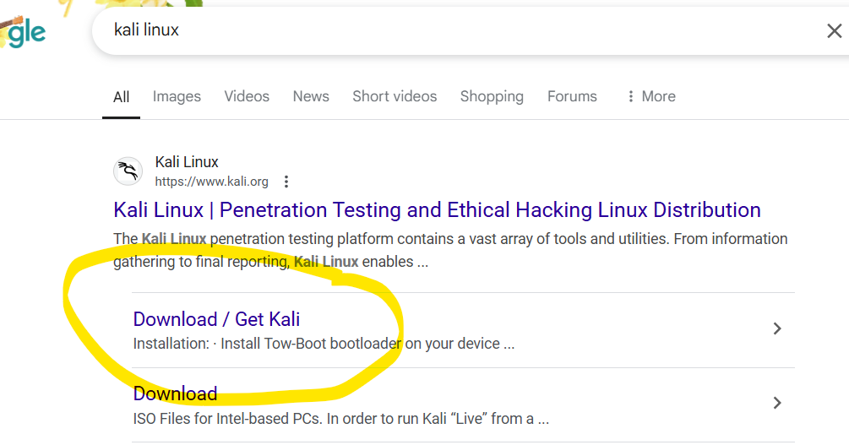

**STEP2:** It is advisable to choose the Virtual Machines option. The reason is because the virtual machines option already comes with preinstalled versions of Kali. We just have to import it on our virtual box. It bypasses the whole installation process.

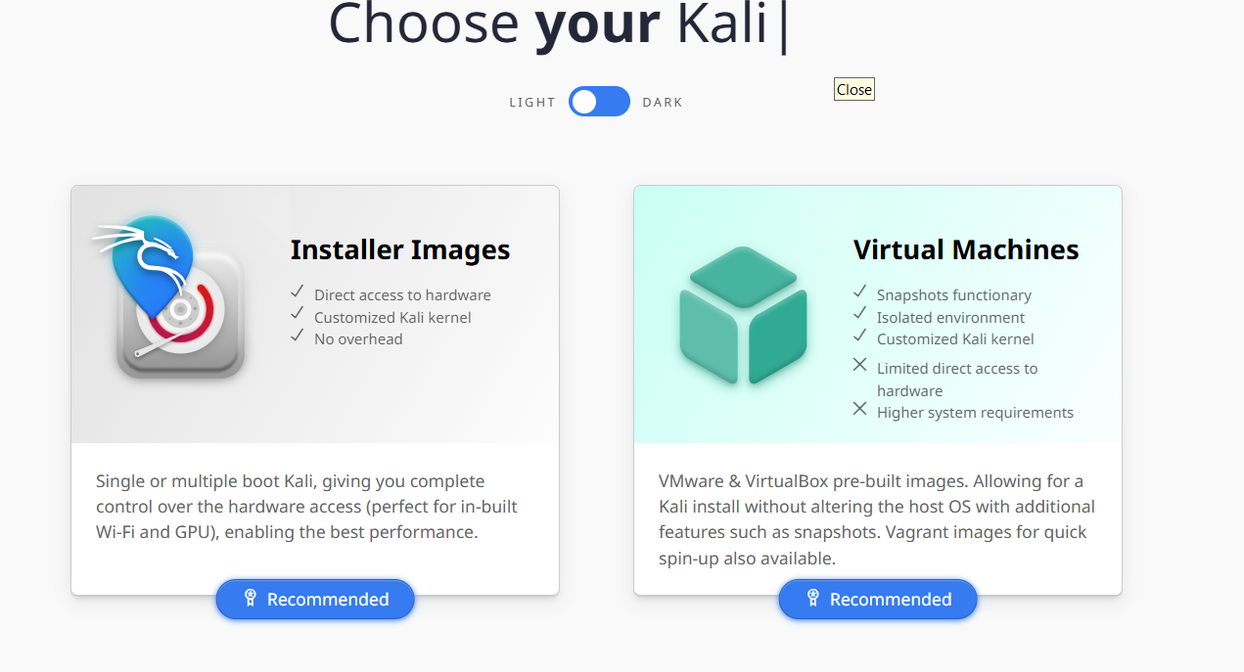

**STEP3: It will take a while to download, depending on your internet speed**

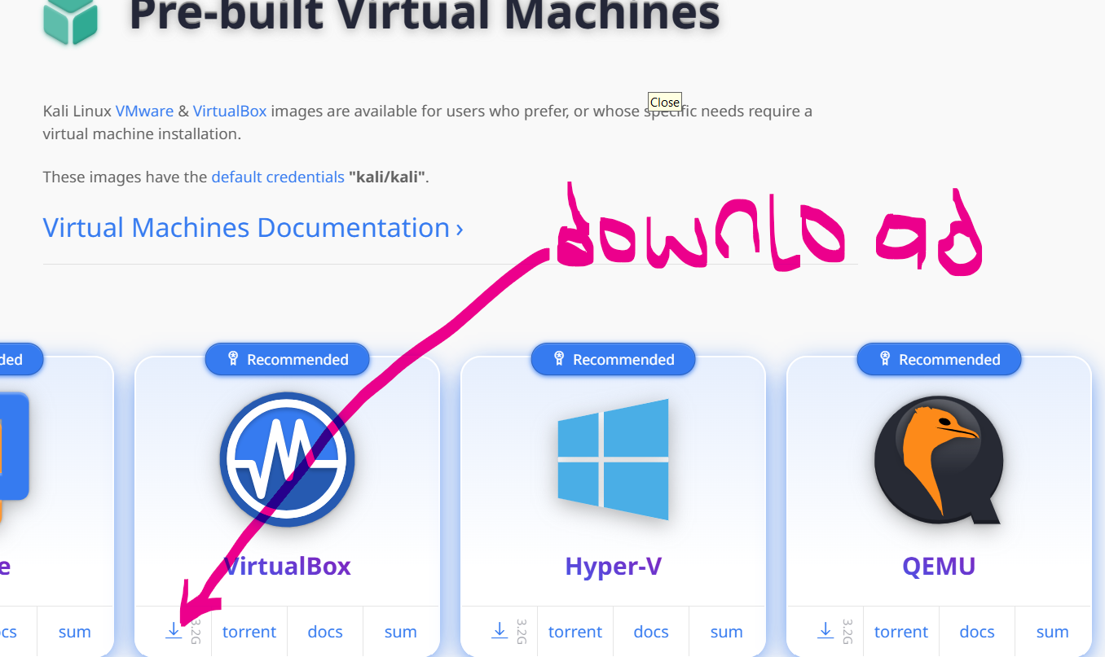

**STEP4: open up virtual box**

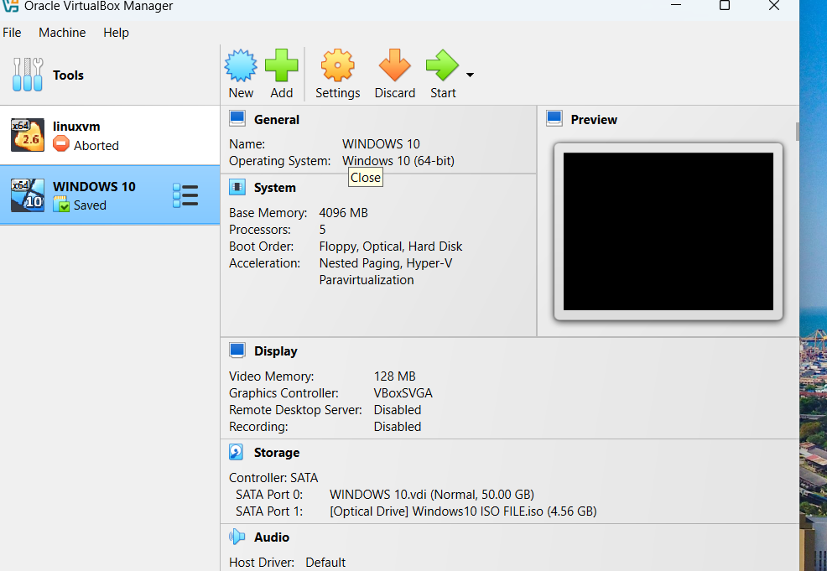

**STEP5:** Drag the Kali Linux file from Download folder to desktop. Then extract the zipped file

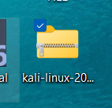

Open the extracted file

**STEP6: Double click to mount**

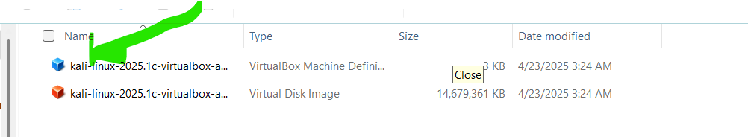

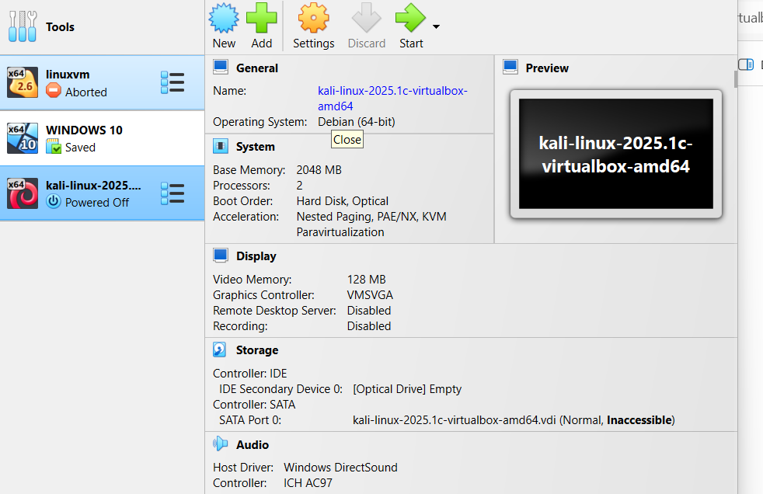

You can increase the RAM to 4GB

Username and password is kali

